**1)Total Revenue**

select round(sum(itv_revenue_crores),2) as total_revenue_crores from fact_itv_metrics;

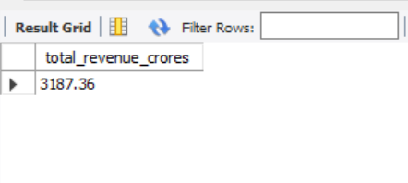

**2)Avg Revenue**

select round(avg(itv_revenue_crores),2) as avg_revenue_crores from fact_itv_metrics;

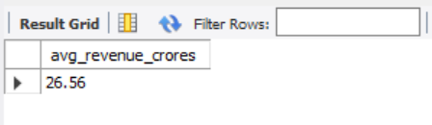

**3)Avg of arpu**

select avg(arpu) as Avg_revenue_per_user from fact_itv_metrics;

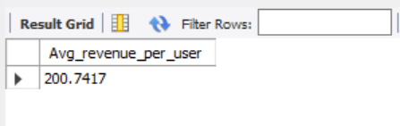

**4)Total Active Users**

select round(sum(active_users_lakhs),2) as Total_active_users_lakhs from fact_itv_metrics;

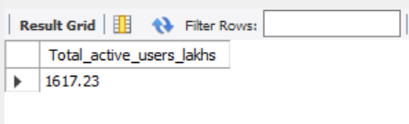

**5)Total Unsubscribed Users**

select round(sum(unsubscribed_users_lakhs),2) as Total_Unsubscribed_Users_lakhs from fact_itv_metrics;

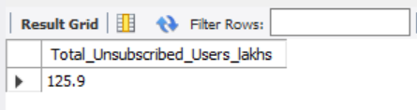

**6)Average of active users per month**

select month_name,round(avg(active_users_lakhs),2) as active_users_per_month_lakh from fact_itv_metrics join dim_date

on substring_index(dim_date.date,'0',-1)=fact_itv_metrics.date

group by month_name;

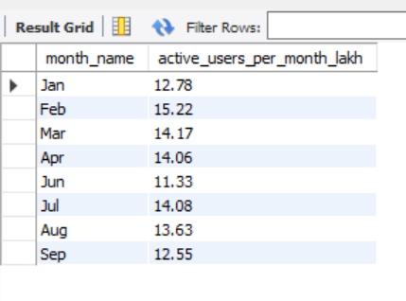

**7)Average of ms_pct**

select round(avg(ms_pct)) as Market_Share_percentage from fact_market_share;

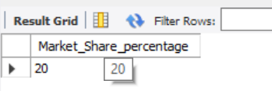

**8)Total Revenue for all periods before 5G implementation**

select time_period,round(sum(itv_revenue_crores),2) from fact_itv_metrics

join dim_date on fact_itv_metrics.date=substring_index(dim_date.date,'0',-1)

where dim_date.`before/after_5G`="Before 5G"

group by time_period;

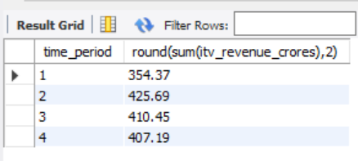

**9)Total Revenue for all periods after 5G implementation**

select time_period,round(sum(itv_revenue_crores),2) from fact_itv_metrics

inner join dim_date on fact_itv_metrics.date=substring_index(dim_date.date,'0',-1)

where dim_date.`before/after_5G`="After 5G"

group by time_period;

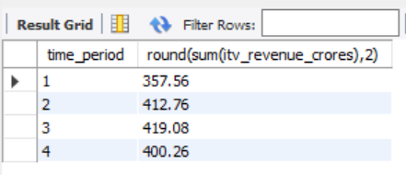

**10)ARPU of periods before 5G implementation**

select time_period,avg(arpu) from fact_itv_metrics

inner join dim_date on fact_itv_metrics.date=substring_index(dim_date.date,'0',-1)

where dim_date.`before/after_5G`="Before 5G"

group by time_period;

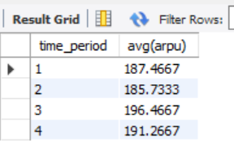

**11)ARPU of periods after 5G implementation**

select time_period,avg(arpu) from fact_itv_metrics

inner join dim_date on fact_itv_metrics.date=substring_index(dim_date.date,'0',-1)

where dim_date.`before/after_5G`="After 5G"

group by time_period;

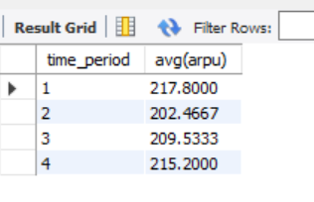

**12)Total active users for all periods before 5G implementation**

select time_period,round(sum(active_users_lakhs),2) from fact_itv_metrics

inner join dim_date on fact_itv_metrics.date=substring_index(dim_date.date,'0',-1)

where dim_date.`before/after_5G`="Before 5G"

group by time_period;

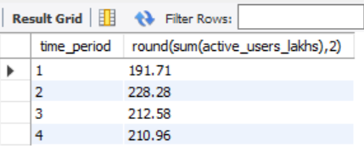

**13)Total active users for all periods after 5G implementation**

select time_period,round(sum(active_users_lakhs),2) from fact_itv_metrics

inner join dim_date on fact_itv_metrics.date=substring_index(dim_date.date,'0',-1)

where dim_date.`before/after_5G`="After 5G"

group by time_period;

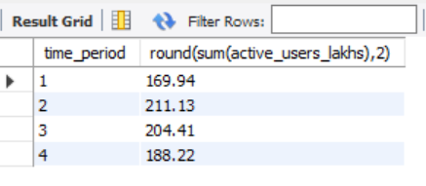

**14)Total unsubscribed users for all periods before 5G implementation**

select time_period,round(sum(unsubscribed_users_lakhs),2) from fact_itv_metrics

inner join dim_date on fact_itv_metrics.date=substring_index(dim_date.date,'0',-1)

where dim_date.`before/after_5G`="Before 5G"

group by time_period;

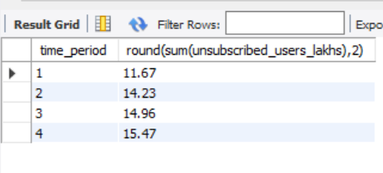

**15)Total unsubscribed users for all periods before 5G implementation**

select time_period,round(sum(unsubscribed_users_lakhs),2) from fact_itv_metrics

inner join dim_date on fact_itv_metrics.date=substring_index(dim_date.date,'0',-1)

where dim_date.`before/after_5G`="After 5G"

group by time_period;

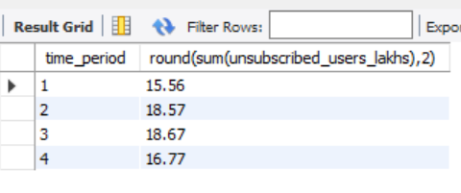

**# 1.Percentage growth in revenue before and after 5g implementation for each city**

WITH RevenueByPeriod AS (

SELECT

dim_cities.city_name,

SUM(CASE WHEN dim_date.`before/after_5g` = 'before 5g' THEN fact_itv_metrics.itv_revenue_crores ELSE 0 END) AS revenue_before_5g,

SUM(CASE WHEN dim_date.`before/after_5g` = 'after 5g' THEN fact_itv_metrics.itv_revenue_crores ELSE 0 END) AS revenue_after_5g

FROM

fact_itv_metrics

JOIN

dim_date ON fact_itv_metrics.date = substring_index(dim_date.date, 0, -1)

JOIN

dim_cities ON fact_itv_metrics.city_code = dim_cities.city_code

GROUP BY

dim_cities.city_name

)

SELECT

city_name,

revenue_before_5g,

revenue_after_5g,

ROUND(

(revenue_after_5g - revenue_before_5g) / NULLIF(revenue_before_5g, 0) * 100,

2

) AS percentage_growth

FROM

RevenueByPeriod;

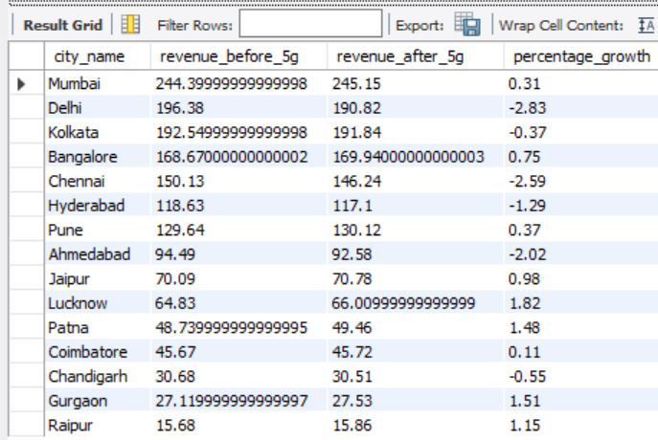

**# 2.Percentage growth in revenue before and after 5g implementation for each Plan**

WITH RevenueByPeriod AS (

SELECT

dim_plan.plan,

SUM(CASE WHEN dim_date.`before/after_5g` = 'before 5g' THEN plan_revenue_crores ELSE 0 END) AS revenue_before_5g,

SUM(CASE WHEN dim_date.`before/after_5g` = 'after 5g' THEN plan_revenue_crores ELSE 0 END) AS revenue_after_5g

FROM

fact_plan_revenue

JOIN

dim_date ON fact_plan_revenue.date =dim_date.date

JOIN

dim_plan ON fact_plan_revenue.plans = dim_plan.plan

GROUP BY

dim_plan.plan

)

SELECT

plan,

revenue_before_5g,

revenue_after_5g,

ROUND(

(revenue_after_5g - revenue_before_5g) / NULLIF(revenue_before_5g, 0) * 100,

2

) AS percentage_growth

FROM

RevenueByPeriod;

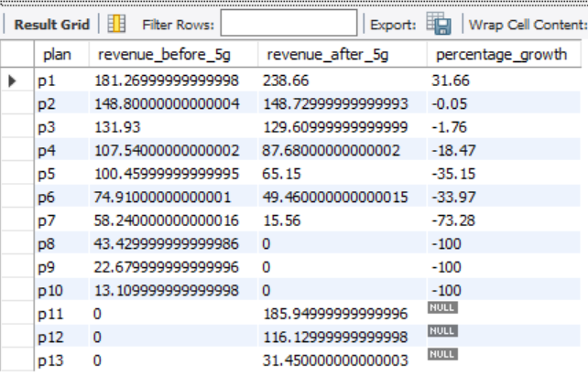

**# 3.City wise active users in lakh before 5g and after 5g**

with right_table as

(select city_name, `before/after_5g`, sum(active_users_lakhs)

from fact_itv_metrics

join dim_cities

on fact_itv_metrics.city_code = dim_cities.city_code

join dim_date on fact_itv_metrics.date = substring_index(dim_date.date, '0', -1) group by city_name ,

`before/after_5g`)

select city_name ,

sum(case when `before/after_5g` = 'Before 5G' then `sum(active_users_lakhs)` end) as before_5g,

sum(case when `before/after_5g` = 'After 5G' then `sum(active_users_lakhs)` end) as After_5g

from right_table group by city_name;

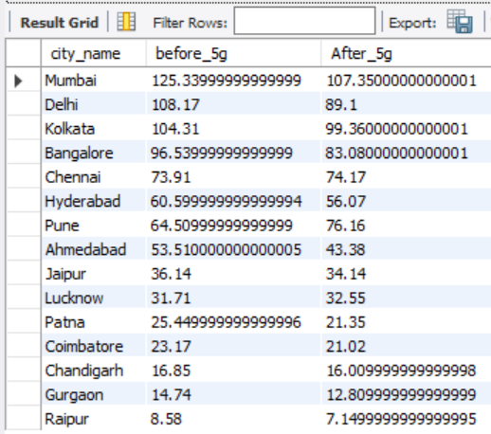

**# 4.Market share over months for all companies**

select month_name,

avg(case when fact_market_share.`company`="itv" then ms_pct end) as itv_marketshare,

avg(case when fact_market_share.`company`="Aiirtel" then ms_pct end) as Aiirtel_marketshare,

avg(case when fact_market_share.`company`="Lio" then ms_pct end) as Lio_marketshare,

avg(case when fact_market_share.`company`="DADAFONE" then ms_pct end) as DADAFONE_marketshare,

avg(case when fact_market_share.`company`="Others" then ms_pct end) as Others_marketshare

from fact_market_share join dim_date on substring_index(dim_date.date,'0',-1)=fact_market_share.date

group by month_name;

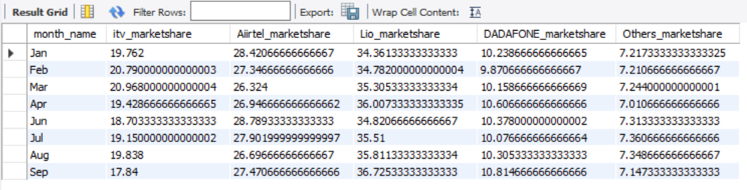

**# 5.Top Plans by revenue**

select plans,sum(plan_revenue_crores) as revenue from fact_plan_revenue

group by plans;

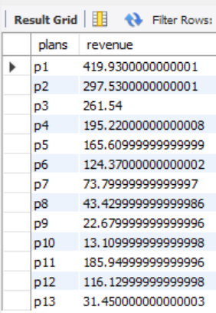

**# 6.Monthly trend of avg ARPU before and after 5g**

SELECT month_name,

avg(CASE WHEN `before/after_5g` = 'Before 5G' THEN arpu END) AS Avg_arpu_before_5g,

avg(CASE WHEN `before/after_5g` = 'After 5G' THEN arpu END) AS Avg_arpu_after_5g

FROM fact_itv_metrics join dim_date on fact_itv_metrics.date=substring_index(dim_date.date, '0', -1)

GROUP BY dim_date.month_name;

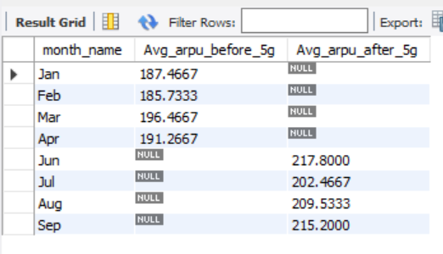

**# 7.Monthly trend of avg active users before and after 5g**

select month_name,

avg(case when `before/after_5G`="Before 5G" then active_users_lakhs end) as avg_activeuser_before_5g,

avg(case when `before/after_5G`="After 5G" then active_users_lakhs end) as avg_activeuser_before_5g

from fact_itv_metrics join dim_date on fact_itv_metrics.date=substring_index(dim_date.date, '0', -1)

group by dim_date.month_name;

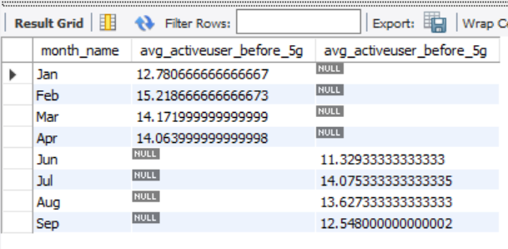

**# 8.Monthly trend of unsubscribed users before 5g and after 5g**

select month_name,

sum(case when `before/after_5G`="Before 5G" then unsubscribed_users_lakhs end) as unsubUser_before_5g,

sum(case when `before/after_5G`="After 5G" then unsubscribed_users_lakhs end) as unsubUser_after_5g

from fact_itv_metrics join dim_date on fact_itv_metrics.date=substring_index(dim_date.date, '0', -1)

group by month_name;

